Women and the Family in Nazi Germany

‘The mission of women is to be beautiful and to bring children into the world. This is not as
un-modern as it sounds. The female bird preens herself for her mate and hatches eggs for him. In exchange, the male takes care of gathering food, and stands guard and wards off the enemy.’
Joseph Goebbels, 1929

Life for women in Weimar Germany

The Weimar Republic had a very progressive attitude towards women’s rights. Women, as well as men, were entitled to vote from the age of 20. In many other European countries at this time this type of equality was but a distant dream. For example, in Britain many women had to wait until the age of 30 to vote, while all men over 21 enjoyed this democratic right. Women were also encouraged to stand for election to the Reichstag. By 1933 10% of Reichstag members were female.

In the Weimar period women were also encouraged to enter into professional careers. Many women became teachers, doctors, lawyers, judges and civil servants. By 1933 there were 100,000 women teachers and 3,000 women doctors. Again, this was a very progressive move, as in many European countries women mainly occupied less well paid jobs such as cleaners, cooks and office secretaries.

Women’s fashion flourished in Weimar Germany, and clothing and make up which celebrated the female form were encouraged.

The Nazi View of Women

The Nazis, however, had very old fashioned views of women’s place in society. They emphasised the differences between men and women and believed that nature had created each for different purposes. They believed that men should be the breadwinners and earn a living to support their families. Men were also to be responsible for decision making and providing protection, e.g. during times of war. They believed women’s role in life should be to bear many children and ensure the domestic comfort of their families, e.g. cooking and cleaning. Women were expected to be dependent on men both financially and emotionally, and to obey their husbands. Women should not be involved in politics, the Nazis believed. They soon took away women’s right to vote. The Nazis also felt it was wrong for women to enter paid employment for two main reasons. Firstly, this would mean neglecting their family duties. Secondly, every woman in employment was seen as taking a job from a man.

The Nazis directed a large volume of propaganda at women to encourage them to lead the kind of lives the Nazis approved of. They often used the propaganda slogan ‘Kinder, Kirche, Kueche’ to sum up what they thought a woman’s role was. Directly translated this means ‘Children, Church and Cooking’.

To the Nazis the ideal physical appearance of a woman was blonde, blue eyed and sturdily built. She was expected to have broad hips for child bearing, and to have no interest in such things as fashion, make up or slimming.

There was no question of equality under the Nazis. Women were squeezed out of jobs soon after Hitler came to power. Women doctors and civil servants were the first to go. Female teachers were not appointed. Women were forbidden from becoming judges or lawyers as they were considered too emotional.

- Describe the type of lifestyle that the Nazis wanted German women to enjoy.

Women as the key to achieving a Nazi community

The Nazis may have been old fashioned in their attitudes to women, but they were not ‘anti-women’ in the slightest. Indeed, Hitler believed that the role of the woman as mother and nurturer of the future generation was a key foundation upon which the Nazis could build a ‘Volksgemeinschaft’ or people’s community.

The Volksgemeinschaft was one of Hitler’s most important ideas about the future of Germany. It centred on the belief that Germany was still a divided nation in the aftermath of the First World War, and that the Nazis could unite the nation by making people feel as though they were part of a very important community. The Nazis would make the German people feel they were important by stressing that Germans belonged to the ‘Master Race’, the strongest and most noble race on Earth. As a member of the ‘Master Race’ one of any Aryan German’s top priorities should be to have children, to ensure the ‘Master Race’ got bigger and bigger, and more and more powerful. In the idea of the ‘Volksgemeinschaft’ the role of women as mothers was seen as one of the most valuable contributions to society.

2. How important were women to the Nazi vision of a perfect future
society? Explain your answer fully using examples from the text.

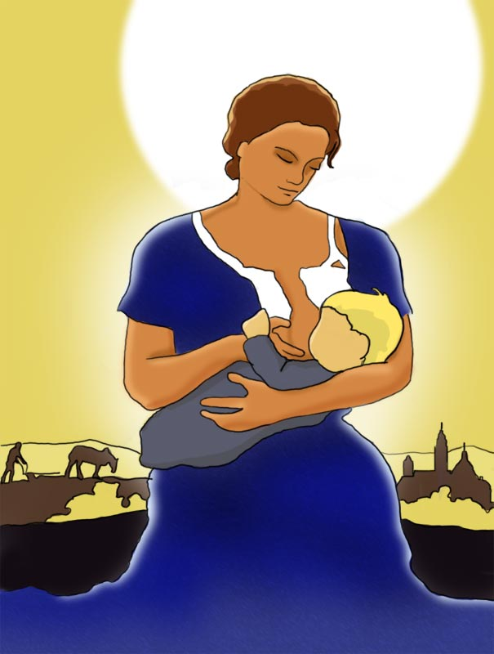

Nazi Policies

Nazi policy towards women was based upon two ‘fears’.
Firstly, the Nazis believed the German population was growing too slowly. Germany’s birth rate had fallen from 2 million to 1 million births a year, mainly due to the number of young men who had died in the First World War. This was a major problem for the Nazis as the expansion of the Master Race was one of their main ideas, and would provide the justification for their policy of ‘Lebensraum’, conquering new lands because the Master Race needed more living space. Women, as child bearers, were the key to these two main Nazi ideas.

Secondly, the Nazis were afraid that their ‘Master Race’ was becoming impure due to inter-marriage with ‘inferior’ groups like the Jews or those with disabilities. Women, and their choice of partners, would again be the key to overcoming this perceived problem.
The Nazis therefore made it their policy to
1) encourage more births
2) prevent a weakening of the Master Race.
The steps below outline how they tried to achieve these two goals.

To encourage more births
- Laws against abortion were strictly enforced, birth control clinics were closed down and contraception was banned.
- Generous marriage loans of 600 marks were given to married couples (equivalent to about 9 months wages). After each child born 25% of the loan would be scrapped, so that after 4 children you would not have to pay back anything at all.
- The Nazis only allowed households with four or more children to be called ‘families’.
- Special awards called the Honour Cross were given out to mothers in elaborate annual ceremonies held on Hitler’s mother’s birthday. Women who had 4 children would receive a bronze medal. Those with six children would receive a silver medal. Those with 8 or more children would receive the gold medal.
- Any married couples who failed to produce children were encouraged to divorce and try again with a new mate.
- In 1936 the Nazis began a breeding experiment called Lebensborn. Fit, healthy, single Aryan women were encouraged to visit the Lebensborn centres where they could meet with SS soldiers in a bid to encourage couples to have more ‘Aryan’ children
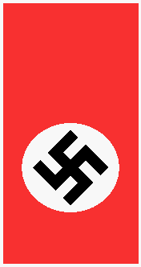

To prevent a weakening of the Master Race

- Welfare support and marriage loans were restricted to Aryans only.
- In 1933 the Nazis began a programme of compulsory sterilisation for all people suffering from blindness, deafness, any physical disability, epilepsy, depression or alcoholism. By 1937 almost 200,000 compulsory sterilisations had been carried out.
- In 1935 the Law for the Protection of German Blood and Honour
(The Nuremberg Laws) banned any marriages or sexual relations between Aryans and Jews. In the same year people suffering from any infectious or hereditary diseases were also banned from marrying or having sexual relations.
- Explain how the Nazis planned to achieve their goals of increasing the birth rate and strengthening the Master Race.

How successful were Nazi policies towards women?
Between 1933 and 1939 the number of marriages increased and there was a sharp rise in the birth rate. On the surface, it would appear that the Nazis policies had been successful. However, there is much evidence to show that this is not the case.

- Many historians say the birth rate would have risen without these policies, as Germany’s economy was now performing well and the birth rate traditionally goes up when the economy does well.
- The birth rate was still only 1.5 million births per year, which was still far short of the pre-war level.
- Some women, including even Nazi party members, did rebel against Nazi policies towards them. Some secretly joined the underground SPD or Communist parties, arguing that women had their own unique talents and should not be confined to the home. Others flouted the laws against women in employment. However, the work they managed to get was usually low paid and low skilled.
- Despite initially driving women out of paid employment the Nazis were later forced to abandon this policy. In 1933 there were 11 ½ million women in work. This actually rose to 12 ½ million by 1939 as women were needed in the workplace to fill the shoes of the millions of German men conscripted to fight in the Second World War. However, we can see this as a temporary situation. If the Nazis had won the war it is unlikely that they would have allowed women to stay in employment once their men folk had returned home.

4. Use all the information you have gathered to answer the following question.
‘Describe the role of women in Nazi Germany’ (3)

